INFORMATION SHEET
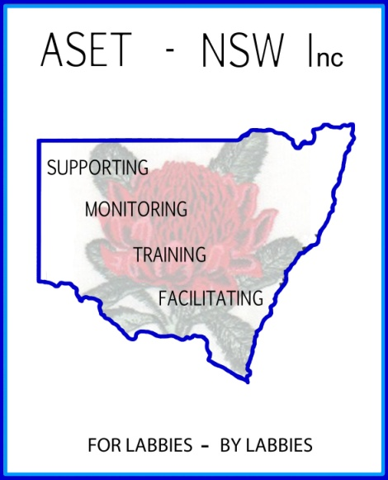
Professional Development Day
Monday 19th and Tuesday 20th September 2016 – 8.00am – 3.15pm
Registration: 8.00am for 8.30am start
Sydney Grammar School, College Street. Darlinghurst.

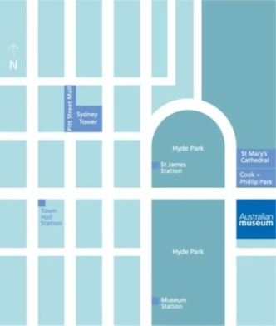

Location , Parking and Public Transport
Sydney Grammar School is located on College Street in central Sydney, next to the Australian Museum and just across the road from Hyde Park.

The nearest train stations are St. James, Museum and Town Hall.
There are three parking stations within easy walking distance of the school.
Secure Parking, Riley Street
Domain Car Park, St Mary's Road
Enacon Parking, Cathedral St (under Cook and Phillip Park)

Entrance to the School

Please enter through the gates on College St and follow the signs on the driveway around the side of the building. Follow the signs and directions from here to the registration area.
Refreshments
Morning Tea (10.50 am Mon / 9.45 am Tues) and Lunch (12.40 pm Mon / 12.25 pm Tues) will be provided
Additional requests
Please note that Sydney Grammar School is a smoke free zone and the school also requests that participants wear appropriate footwear as the workshops are in laboratories.
Contact Numbers:
Chairperson: Margaret Croucher 0405244862 Secretary: Julie Wells 0402788476

